MATHEMATICS DEPARTMENT 2015
Year 11 Specialist - Test Number 6
Resource Free
Transformations and Trigonometric Functions



Name: _______________________________ Teacher: DDA
Marks: 28
Time Allowed: 25 minutes
Instructions: You are permitted no notes or calculators.
_________________________________________________________________________
8multiple-choice questions
1 mark each: 8 marks
Circle the correct answer.
1 What is the matrix for the translation of A(2, 5) B(–3, 3) Aʹ(4, 3) Bʹ(–1, 1)?
A
B
C
D
E

[1 mark]
2 What is the transformation for the matrix?
A (x, y) (2y – 3x, 2x – y)
B (x, y) (3x – 2y, 2x – y)
C (x, y) (2y – 2x, 3x – y)
D (x, y) (3y – 2x, 2x – y)
E (x, y) (2x – 2y, 3x – y)

[1 mark]

3 What is the image of the triangle A(6, 4) B(2, 6) C(8, 12) under the dilation with factor 0.5 in the x-direction and 2 in the y-direction?
A Aʹ(12, 8) Bʹ(4, 12) Cʹ(16, 24)
B Aʹ(12, 2) Bʹ(4, 3) Cʹ(16, 6)
C Aʹ(3, 8) Bʹ(1, 12) Cʹ(4, 24)
D Aʹ(3, 2) Bʹ(1, 3) Cʹ(4, 6)
E Aʹ(3, –8) Bʹ(1, –12) Cʹ(4, –24)

[1 mark]
4 What is the matrix for a rotation of ?
A
B
C
D
E

[1 mark]
5 The amplitude of the graph y = –3 sin is:
A 2
B –2
C 3
D –3
E 4
[1 mark]

6 The period of the graph y = 5 sin is:
A π
B
C 2π
D
E

[1 mark]
7 The amplitude, period and phase shift of the graph y = 2 sin are respectively:
A 2, π, horizontally to the left
B –2, π, horizontally to the right
C π, 2, horizontally to the left
D 2, 2π, horizontally to the left
E 2, 2π, horizontally to the right

[1 mark]
8 The period and phase shift of the graph y = 2 cos (4x – π) are respectively:
A 4π, π horizontally to the left
B , horizontally to the right
C , horizontally to the left
D , π horizontally to the right
E , π horizontally to the left

[1 mark]

4 short answer questions
20 marks
Show your working where appropriate.
9 T1 is a reflection in the line through the origin with inclination .
T2 is a reflection in the line through the origin with inclination .
a Find $T_{1}$

b Find $T_{2}$

c Express the transformation T1 T2 as a matrix.

d What kind of transformation is T1 T2?

[2,2,2,2: 8 marks]

10 The transformation T is represented by the matrix $\left[\begin{matrix}1 & 0 \\ 0 & -1\end{matrix}\right]$
- Describe in words the transformation T.
- The transformation T is applied to the line with equation $y=x$. Find the equation of the resulting line.
- The point A is mapped to the point with coordinates (k, k + 1) under transformation T. Find the coordinates of the point A.
- What is the transformation matrix for dilation of factor 3 in the x-direction?

[4 marks]
11 For the function below, answer the following questions for 0 ≤ x ≤ 2 π.
 | What is the maximum value? | For what value(s) of x does the maximum occur? | What is the minimum value? | For what value(s) of x does the minimum occur?
y = –1 – 4 cos (x – π)

[4 marks]

12 Solve for all values of$θ: tan \left(2θ+\frac{π}{6}\right)=-1$.

[4 marks]

MATHEMATICS DEPARTMENT 2015
Year 11 Specialist - Test Number 6
Resource Rich
Transformations and Trigonometric Functions



Name: _______________________________ Teacher: DDA
Marks: 20
Time Allowed: 20 minutes
Instructions: You are permitted 1 A4 page of notes and your calculators. Show your working where appropriate.
_________________________________________________________________________
13 Using a calculator, solve the equation = 1 for 0 ≤ x ≤ π.

[1 mark]
14 Given transformation matrix T = $\left[\begin{matrix}4 & -3 \\ 1 & 5\end{matrix}\right]$
a Find the image of the trapezium A(3, –2) B(5, 3) C(1, 6) D(–3, –4) under the transformation T.
A’=
B’=
C’=
D’=
c What shape is the image?

[4,1: 5 marks]

15 The area of the triangle ABC is 27.5 cm². Find the area of the image of the triangle ABC after the transformation T: (x, y) $→$ (4x – y, 2x + 5y).
[3 marks]
16 The displacement of a particle is given by x = 3 sin (2t) + cos (2t).
a Express the displacement in the form x = r sin (2t + $α$) giving r in exact form and $α$ to 2 decimal places and in radians.
[5 marks]

b Hence find the greatest distance that this motion reaches from the mean point.

[1 mark]

17 The time between successive high tides at a pier is 12 h 34 min. The average depth of water is 4 m, but at low tide it is 3.1 m. The tide can be modelled by $y=a\cos\left(x-1\right)+b$
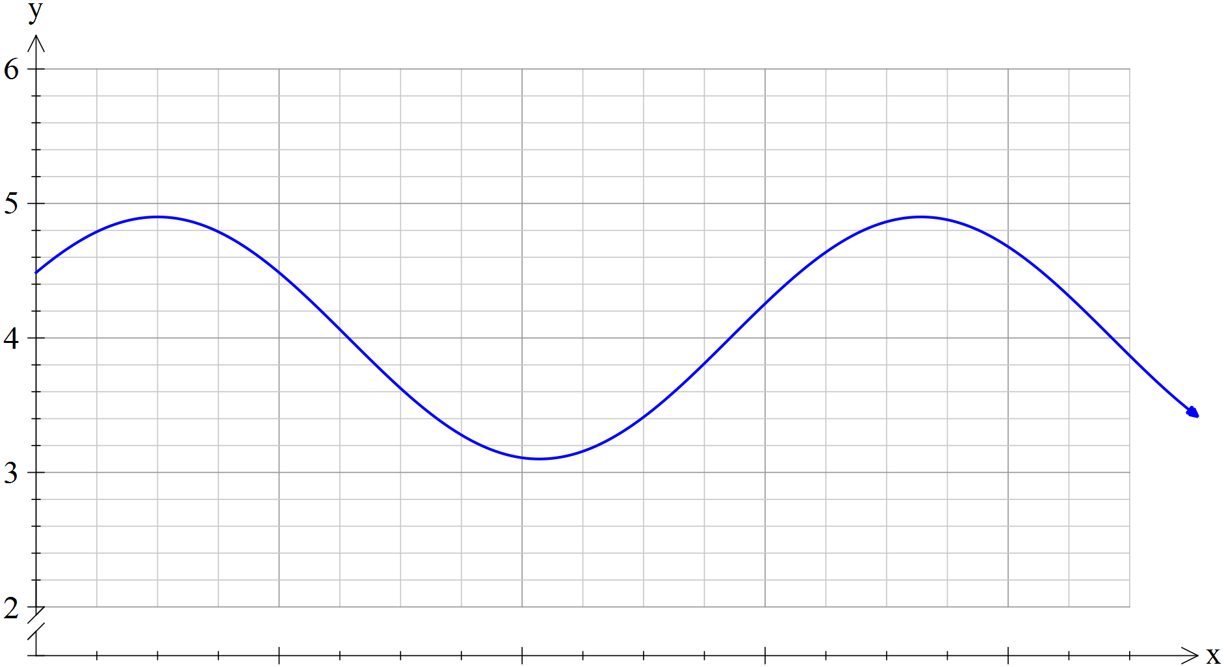

- Determine the values of $a$ and $b$ in the equation.

- Find the length of time that a boat can use the pier if it is only able to dock when the tide is between 3.5 and 4.5 metres.

[5 marks]

